# Acknowledgement

We would like to express our special thanks of gratitude to our lecturer Mrs. Iromi Randika who gave us the golden opportunity to do this wonderful project of E Commerce course unit. We came to know about so many new things while we are developing this project. We sincerely appreciate the encouragement and support given by you as a project coordinator during the web development. Secondly, we would also thank to our friends who helped us a lot to finish this project within the limited time frame.

# Abstract

Our project is Digimart, is a website which helps customer to find and buy all type of electronics on internet. It is useful in the way that it makes an easier way to buy and sell electronic device online. Digimart is an interactive e-commerce solution providing users with an opportunity to buy and sell electronic device is the online platform which deals with new and old parts of all models. In this website we have basically two modules. The first module includes the customer module and second module includes admin module. The customer must register for any enquiry related to parts. The registered customer can view details of device and he/she can buy or sell the device of his/her need. He/she must pay and will get home delivery. The admin module contains the access of admin page on the website. The admin can change everything in the website. He has ability to add, delete, and update any information regarding the products.

In this report, importance of career planning and mentoring for the university undergraduates are explained and the lack of support in terms of information systems are highlighted. An integrated information system is proposed which will feature portfolio management system, job portal, career manager and e-mentoring mobile application. This system will be developed as a new web-based application with a hybrid mobile application where user can access to the web from anywhere if the internet connection is available. Ultimate aim of this project is to strengthen the ability of customer to find most suitable.

# Declaration

“We certify that this project does not incorporate without acknowledgement, any material previously submitted for an assignment in any institution and to the best of my knowledge and belief, it does not contain any material previously published or written by another person or myself except where due reference is made in the text. I also hereby give consent for my dissertation, if accepted, to be made available for photocopying and for interlibrary loans, and for the title and summary to be made available to outside organizations”

**Index No: Name Signature**

TG/2017/231 W. M. M. M. Bandara _______________

TG/2017/233 W. W. M. S. Karunasena _______________

TG/2017/244 H. S. Dhanujika _______________

TG/2017/258 D. S. Weeraddana _______________

TG/2017/264 S. K. H. R. S. Kumara _______________

TG/2017/277 T. Priyanka _______________

# Table of Contents

Acknowledgement 1

Abstract 1

Declaration 2

Table of Contents 3

List of Figures 4

List of Tables 6

List of Abbreviations 6

Chapter 1: Introduction 7

Introduction to the organization 7

1.2 Need Analysis 8

1.2.1 Problem Definition 8

1.2.2 Solution 9

1.2.3 Project Aim 9

1.3 Objectives 9

1.4 Scope of the project 10

Chapter 2: System Analysis & Design 11

2.1 ER Diagram 11

2.2 Class Diagram 12

2.3 Use Case Diagram 13

2.4 Use Case Description 14

2.5 Activity Diagrams 27

2.6 Sequence Diagrams 44

2.7 Software Requirement Specification 50

2.7.1 Functional Requirement 50

2.7.2 Non-Functional Requirement 51

Chapter 3: Implementation 52

3.1 Technologies 52

3.2 Program Techniques 52

3.3 Coding 52

Chapter 4: Proposed System Interfaces 53

4.1 Proposed System Interfaces 53

4.2 Report Design 59

Conclusion 63

References 63

# List of Figures

Figure 1 - ER Diagram 11

Figure 2 - Class Diagram 12

Figure 3 - Use Case Diagram 13

Figure 4: Activity Diagram - Login 27

Figure 5: Activity Diagram - Logout 27

Figure 6: Activity Diagram - Update Profile 28

Figure 7: Activity Diagram - View Dashboard 28

Figure 8: Activity Diagram - View & Reply contact messages 29

Figure 9: Activity Diagram - Add, Delete & View user account 30

Figure 10: Activity Diagram - View transaction details & Get monthly transaction report 31

Figure 11: Activity Diagram - Add, Delete & View brand, product and category 32

Figure 12: Activity Diagram - View order details & Get daily order report 33

Figure 13: Activity Diagram - Create customer account 34

Figure 14: Activity Diagram - Search & View product 35

Figure 15: Activity Diagram - Add to cart or quotation 36

Figure 16: Activity Diagram - View & Cancel order details 37

Figure 17: Activity Diagram - Get quotation 38

Figure 18: Activity Diagram - Place order for customized product 39

Figure 19: Activity Diagram - Buy product 40

Figure 20: Activity Diagram - Add, Delete & View mail address 41

Figure 21: Activity Diagram - Update, Delete & View payment card 42

Figure 22: Activity Diagram - Send & View messages 43

Figure 23: Sequence Diagram - Login 44

Figure 24: Sequence Diagram - Logout 44

Figure 25: Sequence Diagram – Update Profile 45

Figure 26: Sequence Diagram – View Dashboard 45

Figure 27: Sequence Diagram – Add, Delete & View user account 46

Figure 28: Sequence Diagram – View transaction details & Get monthly transaction report 46

Figure 29: Sequence Diagram – Add, Delete & View brand, product and category 47

Figure 30: Sequence Diagram – View order details & Get daily order report 47

Figure 31: Sequence Diagram – Place order for customized product 48

Figure 32: Sequence Diagram - Buy product 49

Figure 33: Home Page 53

Figure 34: Light Theme 53

Figure 35: Shopping Cart 54

Figure 36: Mail and Payment Information 54

Figure 37: Product View 55

Figure 38: Customer Order Details 55

Figure 39: Add and View Inventory Officer 56

Figure 40: Account Setting 56

Figure 41: Message Center 57

Figure 42: Customize Order Details 57

Figure 43: Add and View Product Brand 58

Figure 44: Customize Product Service 58

Figure 45: Quotation Report 59

Figure 46: Customize Product Quotation Report 60

Figure 47: Daily Confirmed Order Report 61

Figure 48: Daily Confirmed Customize Order Report 62

# List of Tables

Table 1 - Login 13

Table 2 - Logout 14

Table 3 - Update Profile 14

Table 4 - View Dashboard 15

Table 5 - View & Reply contact messages 15

Table 6 - Add, Delete & View user account 16

Table 7 - View transaction details & Get monthly transaction report 17

Table 8 - Add, Delete & View brand, product and category 18

Table 9 - View order details & Get daily order report 18

Table 10 - Create customer account 19

Table 11 - Search & View product 19

Table 12 - Add to cart or quotation 20

Table 13 - View & Cancel order details 21

Table 14 - Get quotation 21

Table 15 - Place order for customized product 22

Table 16 - Buy product 23

Table 17 - Add, Delete & View mail address 24

Table 18 - Update, Delete & View payment card 24

Table 19 - Send & View messages 25

Table 20 - Functional Requirement 46

Table 21 - Non-Functional Requirement 46

# List of Abbreviations

HTML - Hypertext Markup Language

CSS - Cascading Style Sheets

PHP -  Hypertext Preprocessor

# Chapter 1: Introduction

## Introduction to the organization

Established in 2020, DigiMart Computer Solutions has strived to be one of the leading retailers for branded & customizable computers and related products in today’s market. Our valued customers with the latest technology, while providing an excellent service that would culminate in providing you the best available products. DigiMart Computer Solutions has always been the stable backdrop for many PC enthusiasts in the face of rising enthusiasm for high-end computer gaming and custom-built PCs. Thus, enabling the dreams of making one's own computer that would fit all of one's needs come true.

We believe in your passion, as fellow PC enthusiasts, we would be more than glad to provide you with any assistance when you're looking for branded computer solutions. If you visit our store, it would be possible for you to see for yourself the latest products that we have in our showroom, sourced from the international market. We specialize in making available the latest technology as soon as it is released worldwide. In fact, you would be able to observe that most products on our shelves are less than one year old! Whether you are building your own gaming PC or hoping to upgrade the computer you have for your desired purpose, DigiMart Computer Solutions has ability to offer you the ideal solution that will meet your expectations. The premium hardware that we offer would be of outstanding quality and the brands that we choose would speak for themselves. We give you not only the ability to be exposed to such high-end hardware, but also ensure that we offer them at reasonable prices. It is our thought that every individual who has the passion for high-end computers deserves to experience great high-end hardware. With the latest computer products brought from the top-grade brands all over the world, we promise you on delivering the best available options for your dream gaming rig. We have understood what it means to be trusted by thousands of customers, and we intend on keeping that trust by continuing to provide you with the best products for affordable prices. We make it our responsibility to attend to your requirements of structuring the ideal PC for you. The personalized experience that you can have at DigiMart as a customer is unparalleled. The business owners are also actively involved in providing advice to choose and customize your ideal computer.

Our fervent hope would be to let you have the best product for the budget at your hand, and we know that our direct involvement in letting you have a wider understanding on the products would contribute to this greatly. Technology today plays a significant role in evolving the world. at DigiMart Computer Solutions always execute our promises keeping you as our top most priority, and we believe that adapting to the tech scene in the world on par with the international scale has given us the opportunity to be who we are today; a pioneer in the field of computer products in the country.

## 1.2 Need Analysis

### 1.2.1 Problem Definition

We live in a new era, so people tend to customize computer products. Also, sometimes we want get quotation for computer or laptop. To accomplish this purpose, we want to go to shop for that, because there is no online facility to customize computer products and get quotation in Sri Lanka.

We don’t have much enough time to buy computer products when we need it. Because if we want to buy those products we need to go to store and need to waste our valuable time. Also, it costs some travelling charge too. For an example When we want to buy laptop, in the store we must go to the laptop area, at the same time if we want to buy a pen drive, we need to move the area where the pen drive are available. This problem wastes our valuable time by moving here and there and it feels too tired to our body. Also, we need to wait a lot of time in the queue when we are billing our products because that time may crow with people.

This are the problems what we face in the today’s world.

### 1.2.2 Solution

According to those problems we decided to create an online system for computer products, so the customers who can easily watch and order their needy products when they need it even in the night-time. We consider the problems what customer face when they need products and created this system to avoid those problems. So, people don’t need to waste their time, travelling charge and no need to get tired by doing shopping.

The main solution is to create an online facility for customized computer products and get quotation. We hope to add these features in the above mentioned system.

### 1.2.3 Project Aim

Main aim of the project is to facilitate career planning of Faculty of Technology undergraduates by providing them with an integrated information system which will feature electronic website developing

## 1.3 Objectives

* To provide Warranty assured for related products.
* Customize the orders in order to customer requirements.
* Provide the home delivery service to customer.
* To provide the best service available to the community at an affordable price.
* To develop computer customization in next years.
* Constant growth in sales from start up through year three.
* To generate customer satisfaction so that at least 40% of our customer base is repeat business
* Provide Long term services.
* Provide the 24 hours service to customer.

## 1.4 Scope of the project

The proposed software product is the based on computer products. The system can be used in any computer product shop. Digimart System developed on and for the Windows. This project also provides security with the use of Login-in and Password, so that any unauthorized users cannot use your account. The only authorized that will have proper access authority can access the software.

The intention of the system is to reduce customer problems and increase the number of customers that can be loyalty. Requirement statements in these documents are both functional and non-functional.

# Chapter 2: System Analysis & Design

## 2.1 ER Diagram

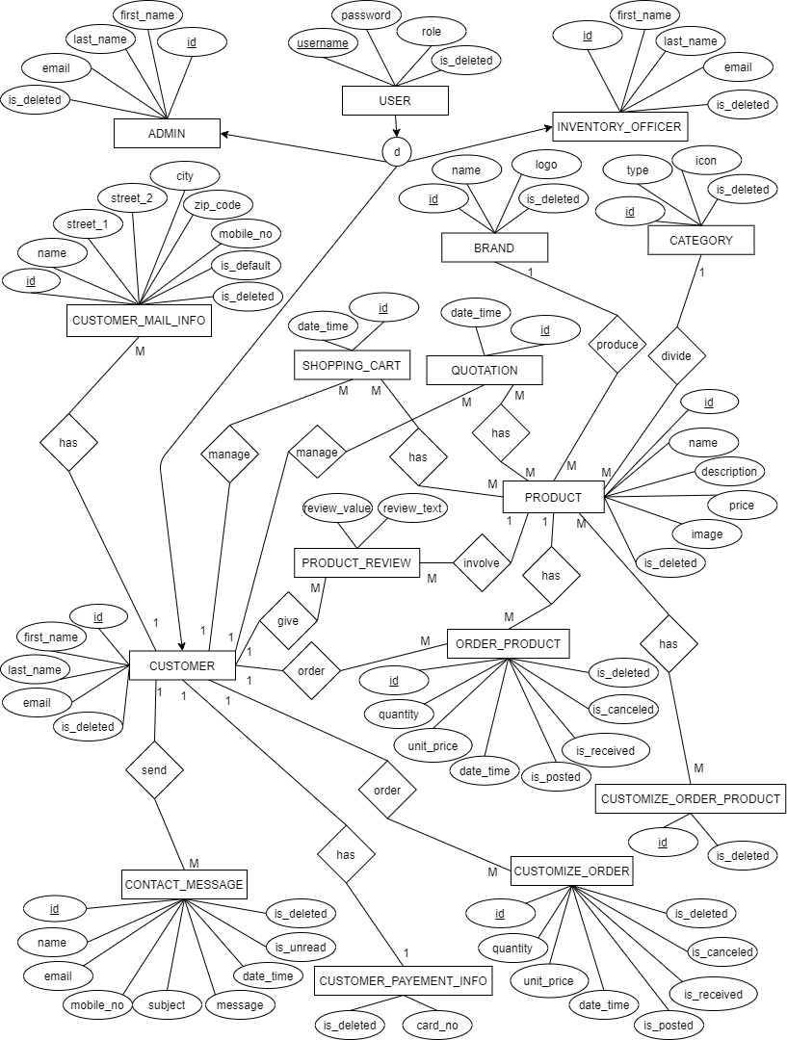

Figure - ER Diagram

## 2.2 Class Diagram

Figure - Class Diagram

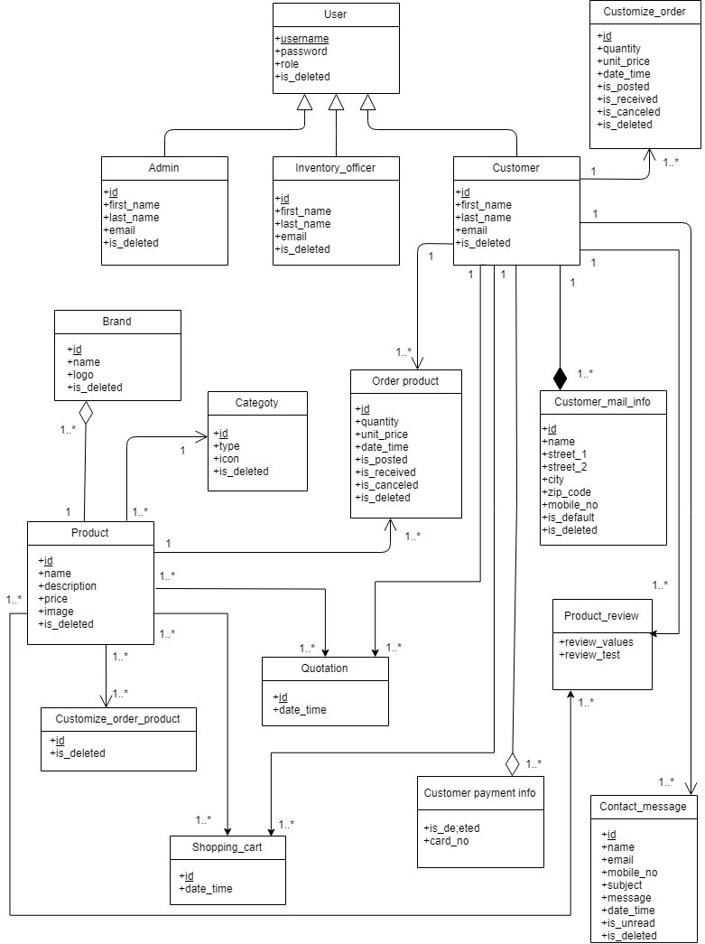

## 2.3 Use Case Diagram

Figure - Use Case Diagram

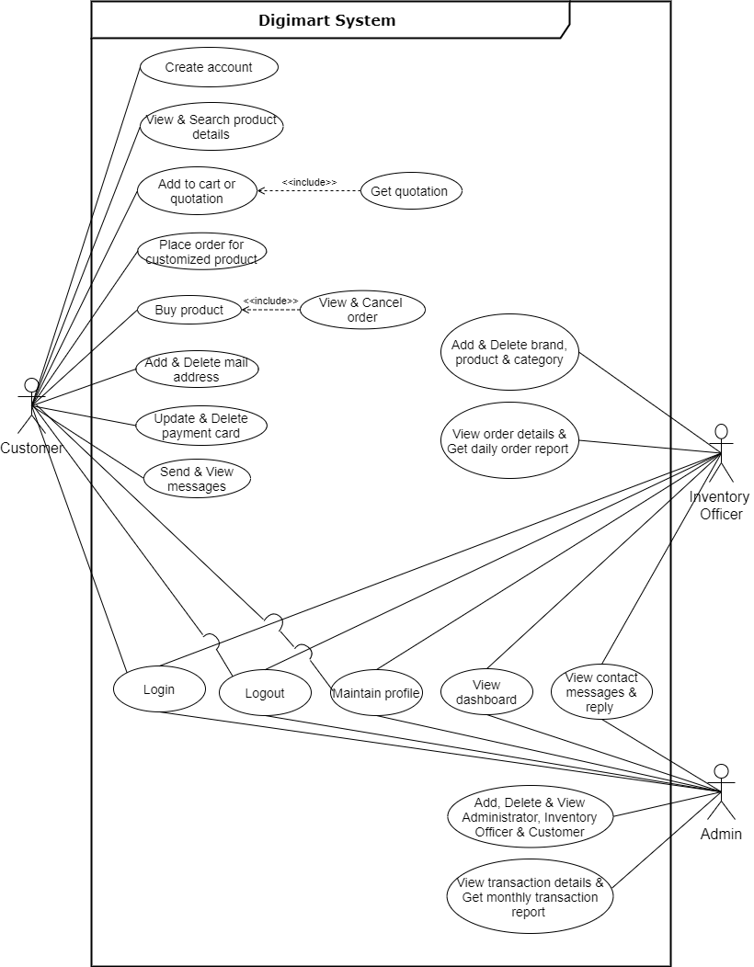

## 2.4 Use Case Description

|  |  |  |
| --- | --- | --- |
| **Use case name** | Login | |
| **Use Case ID** | UC - 01 | |
| **Actor** | Admin, Inventory Officer & Customer | |
| **Precondition** | The user should have username and password. | |
| **Basic course of action** | **User action** | **System response** |
|  | 1. The user opens the ‘login’ page.  3. The user enters the username and password on the form.  4. The user clicks the Sign In button. | 2. The system will display a ‘login’ form that accepts username and password from the user.  5. The system searches the username from the database and matches it with the password.  6. If correct the system opens the authorized page.  8. End use case |
| **Postcondition** | User logs into the system and is allowed to perform other tasks. | |

Table - Login

|  |  |  |
| --- | --- | --- |
| **Use case name** | Logout | |
| **Use Case ID** | UC-02 | |
| **Actor** | Admin, Inventory Officer & Customer | |
| **Precondition** | The user should login first. | |
| **Basic course of action** | **User action** | **System response** |
|  | 1. The user clicks the logout button.  3. The user clicks yes button.  5.End use case. | 2. The system will display message ‘yes’ or ‘no.  4.The system will display the login form for the user. |
| **Postcondition** | Logout from the system and display sign in form. | |

Table - Logout

|  |  |  |
| --- | --- | --- |
| **Use case name** | Update Profile | |
| **Use Case ID** | UC-03 | |
| **Actor** | Admin, Inventory Officer & Customer | |
| **Precondition** | Before the user updates the profile, he/she should go to My Account section. | |
| **Basic course of action** | **User action** | **System response** |
|  | 1. The user opens the ‘My Account Setting’ page.  4. The user change details and clicks ‘Change Name’ or ‘Change Password’. | 2. The system will display user information.  6.The system will update profile details and displays message.  7. End use case. |
| **Postcondition** |  | |

Table - Update Profile

|  |  |  |
| --- | --- | --- |
| **Use case name** | View Dashboard | |
| **Use Case ID** | UC- 04 | |
| **Actor** | Admin, Inventory Officer | |
| **Precondition** | Before the user views the dashboard, he/she should go to Manage Digimart section. | |
| **Basic course of action** | **User action** | **System response** |
|  | 1. The user opens the ‘Dashboard’ page. | 2. The system will display dashboard  3. End use case |
| **Postcondition** |  | |

Table - View Dashboard

|  |  |  |
| --- | --- | --- |
| **Use case name** | View & Reply contact messages | |
| **Use Case ID** | UC-05 | |
| **Actor** | Admin, Inventory Officer | |
| **Precondition** | Before the user updates the profile, he/she should go to My Account and Message Center section. | |
| **Basic course of action** | **User action** | **System response** |
|  | 1. The user opens the ‘Contact Message’ page.  3. The user opens the ‘Message Center’ page.  5. Type reply message and clicks ‘Send’ image button. | 2. The system will display contact messages.  4. The system will display contact messages.  6. The system will update database  7. End use case. |
| **Postcondition** |  | |

Table - View & Reply contact messages

|  |  |  |
| --- | --- | --- |
| **Use case name** | Add, Delete & View user account | |
| **Use Case ID** | UC-06 | |
| **Actor** | Admin | |
| **Precondition** | Before the admin creates the user account, he/she should go to Manage Digimart section. | |
| **Basic course of action** | **User action** | **System response** |
|  | 1. The user opens the ‘Administrator’ / ‘Inventory Officer’ / ‘Customer’ page.  3. Clicks ‘Delete’ image button.  6. Provide user details and clicks ‘Submit’ button. | 2. The system will display user details.  4. The system will delete user details and update database.  5. The system will add user details  7. The system will display message and create user account.  8. End use case. |
| **Postcondition** |  | |

Table - Add, Delete & View user account

|  |  |  |
| --- | --- | --- |
| **Use case name** | View transaction details & Get monthly transaction report | |
| **Use Case ID** | UC-07 | |
| **Actor** | Admin | |
| **Precondition** | Before the admin view transaction details & Get monthly transaction report, he/she should go to Manage Digimart section. | |
| **Basic course of action** | **User action** | **System response** |
|  | 1. The user opens the ‘Transaction Details’ page.  3. Clicks the button. | 2. The system will display transaction details and monthly transaction report.  4. The system will display monthly transaction report as a PDF.  7. End use case. |
| **Postcondition** |  | |

Table - View transaction details & Get monthly transaction report

|  |  |  |
| --- | --- | --- |
| **Use case name** | Add, Delete & View brand, product and category | |
| **Use Case ID** | UC-08 | |
| **Actor** | Inventory Officer | |
| **Precondition** | Before the inventory officer creates the brand, product and category, he/she should go to Manage Digimart section. | |
| **Basic course of action** | **User action** | **System response** |
|  | 1. The user opens the ‘Brand’ / ‘Category / ‘Product.  3. Clicks ‘Delete’ image button.  6. Provide brand/ product/ category details and clicks ‘Submit’ button. | 2. The system will display brand/ product/ category details.  4. The system will delete brand/ product/ category details and update database.  5. The system will add brand/ product/ category details  7. The system will display message and create brand/ product/ category.  8. End use case. |
| **Postcondition** |  | |

Table - Add, Delete & View brand, product and category

|  |  |  |
| --- | --- | --- |
| **Use case name** | View order details & Get daily order report | |
| **Use Case ID** | UC-09 | |
| **Actor** | Inventory Officer | |
| **Precondition** | Before the inventory officer view order details & Get daily order report, he/she should go to Manage Digimart section. | |
| **Basic course of action** | **User action** | **System response** |
|  | 1. The user opens the ‘Order Details’ page.  3. Clicks the button. | 2. The system will display order details and daily order report.  4. The system will display daily order report as a PDF.  7. End use case. |
| **Postcondition** |  | |

Table - View order details & Get daily order report

|  |  |  |
| --- | --- | --- |
| **Use case name** | Create customer account | |
| **Use Case ID** | UC-10 | |
| **Actor** | Customer | |
| **Precondition** | Before the customer create an account, he/she should visit to Digimart web page. | |
| **Basic course of action** | **User action** | **System response** |
|  | 1. The user clicks the ‘Join’ button.  3. Provide user details.  5. Clicks ‘Join’ button. | 2. The system will display Join form.  4.If the password matches, the system will display the ‘Join’ button. If not, will display form.  6. The system will create account & log into account.  7. End use case. |
| **Postcondition** | User logs into the system and is allowed to perform other tasks. | |

Table - Create customer account

|  |  |  |
| --- | --- | --- |
| **Use case name** | Search & View product | |
| **Use Case ID** | UC-11 | |
| **Actor** | Customer | |
| **Precondition** | Before the customer search and view product, he/she should visit to Digimart web page or user account. | |
| **Basic course of action** | **User action** | **System response** |
|  | 2. Search product using search bar.  4. Clicks product image. | 1. The system will display products and search bar.  3. The system will display product for relevant search term.  5. The system will display product details.  6. End use case. |
| **Postcondition** |  | |

Table - Search & View product

|  |  |  |
| --- | --- | --- |
| **Use case name** | Add to cart or quotation | |
| **Use Case ID** | UC-12 | |
| **Actor** | Customer | |
| **Precondition** | Before the customer add to cart or quotation, he/she should visit to Digimart web page or user account. | |
| **Basic course of action** | **User action** | **System response** |
|  | 2. Move the cursor o the product image.  4. Clicks the required button. | 1. The system will display products.  3. The system will display ‘Add to Cart’ and ‘Add to Quote’ image button.  5. The system will add the product to the cart or quotation.  6. End use case. |
| **Postcondition** |  | |

Table - Add to cart or quotation

|  |  |  |
| --- | --- | --- |
| **Use case name** | View & Cancel order details | |
| **Use Case ID** | UC-13 | |
| **Actor** | Customer | |
| **Precondition** | Before the customer view & cancel order details, he/she should visit to user account. | |
| **Basic course of action** | **User action** | **System response** |
|  | 2. Clicks ‘Order List’ image button / ‘Account’ image button and request My Order page  4. Clicks the button. | 1. The system will display user account.  3. The system will display order details and ‘Cancel Order’ button.  5. The system will cancel the order & update the database.  6. End use case. |
| **Postcondition** |  | |

Table - View & Cancel order details

|  |  |  |
| --- | --- | --- |
| **Use case name** | Get quotation | |
| **Use Case ID** | UC-14 | |
| **Actor** | Customer | |
| **Precondition** | Before the customer get quotation, he/she should visit to user account. | |
| **Basic course of action** | **User action** | **System response** |
|  | 2. Clicks ‘Quotation’ image button  4. Clicks the checkbox for the required products.  6. Clicks the button. | 1. The system will display user account.  3. The system will display quotation details.  5. The system will display total price and ‘Get quotation as a PDF’ button.  7. The system will display quotation as a PDF.  8. End use case. |
| **Postcondition** |  | |

Table - Get quotation

|  |  |  |
| --- | --- | --- |
| **Use case name** | Place order for customized product | |
| **Use Case ID** | UC-15 | |
| **Actor** | Customer | |
| **Precondition** | Before the customer place order for customized product, he/she should visit to user account. | |
| **Basic course of action** | **User action** | **System response** |
|  | 2. Clicks the button  4. Select the checkbox for the required products.  6. Clicks the button.  8. Provide mail & payment information.  9. Clicks ‘Buy’ button. | 1. The system will display user account and ‘Customize PC’ image button.  3. The system will display Customize PC details.  5. The system will display order summary & ‘Place Order’ button.  7. The system will display payment page  10. The system will accept the order & display order details.  11. End use case. |
| **Postcondition** |  | |

Table - Place order for customized product

|  |  |  |
| --- | --- | --- |
| **Use case name** | Buy product | |
| **Use Case ID** | UC-16 | |
| **Actor** | Customer | |
| **Precondition** | Before the customer buy product, he/she should visit to user account. | |
| **Basic course of action** | **User action** | **System response** |
|  | 2. Clicks the button  4. Select the checkbox for the required products.  6. Clicks the button.  8. Provide mail & payment information.  9. Clicks ‘Buy’ button. | 1. The system will display user account and ‘Shopping Cart’ image button.  3. The system will display Shopping Cart details.  5. The system will display order summary & ‘Buy’ button.  7. The system will display payment page  10. The system will accept the order & display order details.  11. End use case. |
| **Postcondition** |  | |

Table - Buy product

|  |  |  |
| --- | --- | --- |
| **Use case name** | Add, Delete & View mail address | |
| **Use Case ID** | UC-17 | |
| **Actor** | Customer | |
| **Precondition** | Before the customer adds & deletes a mail address, he/she should go to user account. | |
| **Basic course of action** | **User action** | **System response** |
|  | 2. Clicks ‘Account’ image button & request My Mail Address page.  4. Clicks ‘Delete’ image button.  6. Provide mail address details and clicks ‘Add address’ button. | 1. The system will display user account  3. The system will display mail address details.  5. The system will delete mail address details and update database.  7. The system will display message and create mail address.  8. End use case. |
| **Postcondition** |  | |

Table - Add, Delete & View mail address

|  |  |  |
| --- | --- | --- |
| **Use case name** | Update, Delete & View payment card | |
| **Use Case ID** | UC-18 | |
| **Actor** | Customer | |
| **Precondition** | Before the customer updates & deletes a payment card, he/she should go to user account. | |
| **Basic course of action** | **User action** | **System response** |
|  | 2. Clicks ‘Account’ image button & request My Mail Address page.  4. Clicks ‘Delete’ image button.  6. Provide payment card details and clicks ‘Change Card’ button. | 1. The system will display user account  3. The system will display payment card details.  5. The system will delete payment card details and update database.  7. The system will display message, update payment card & the database.  8. End use case. |
| **Postcondition** |  | |

Table - Update, Delete & View payment card

|  |  |  |
| --- | --- | --- |
| **Use case name** | Send & View messages | |
| **Use Case ID** | UC-19 | |
| **Actor** | Customer | |
| **Precondition** | Before the customer send & view messages, he/she should go to user account. | |
| **Basic course of action** | **User action** | **System response** |
|  | 2. Clicks ‘Message’ image button / Clicks ‘Account’ image button & request Message Center page.  4. Type message and clicks ‘Send’ image button. | 1. The system will display user account  3. The system will display message area.  5. The system will update database.  6. End use case. |
| **Postcondition** |  | |

Table - Send & View messages

## 2.5 Activity Diagrams

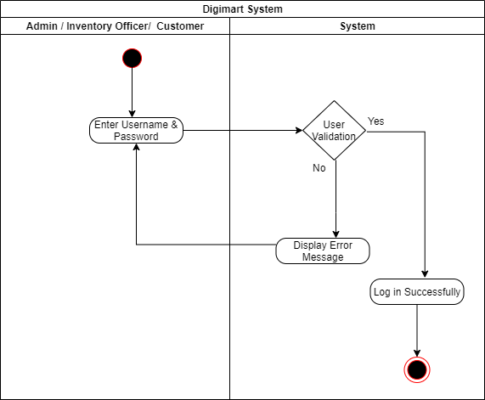

Figure : Activity Diagram - Login

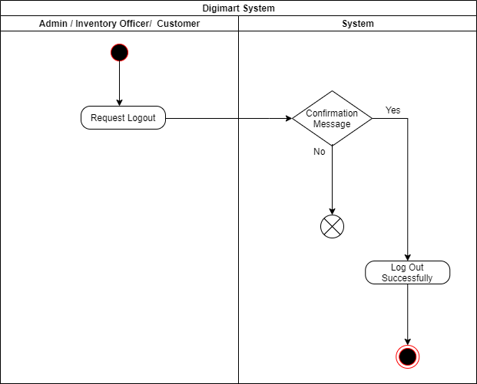

Figure : Activity Diagram - Logout

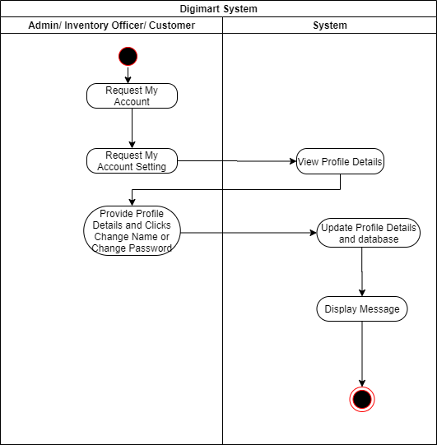

Figure : Activity Diagram - Update Profile

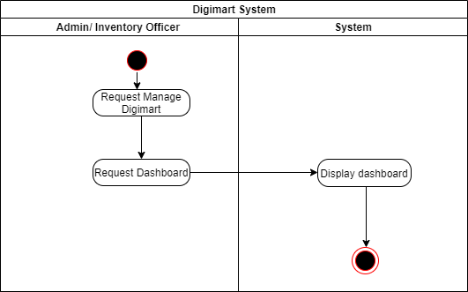

Figure : Activity Diagram - View Dashboard

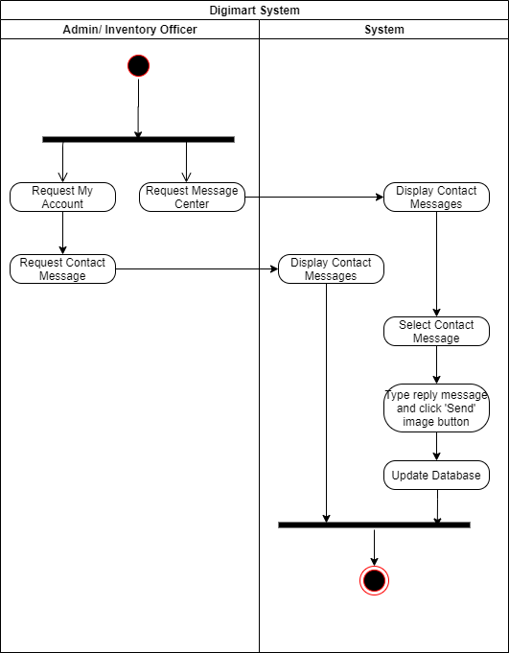

Figure : Activity Diagram - View & Reply contact messages

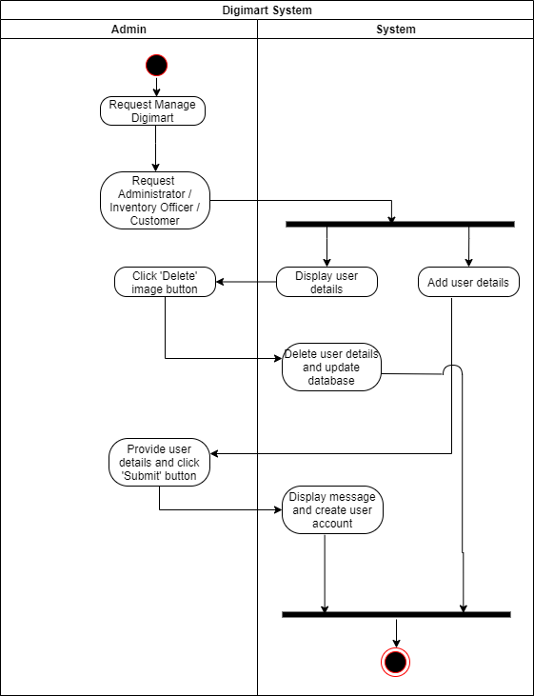

Figure : Activity Diagram - Add, Delete & View user account

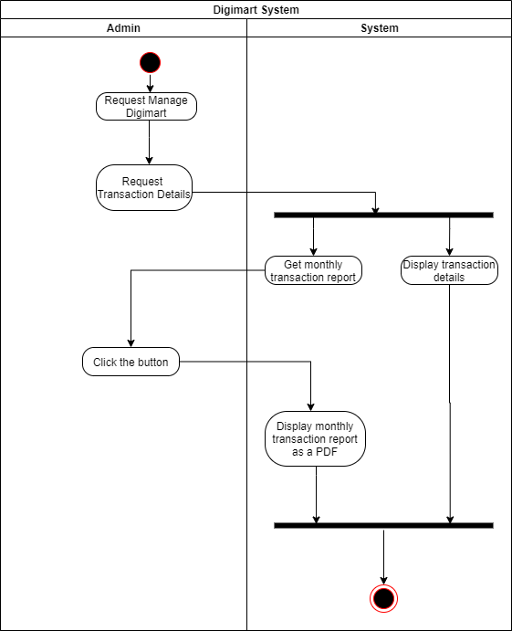

Figure : Activity Diagram - View transaction details & Get monthly transaction report

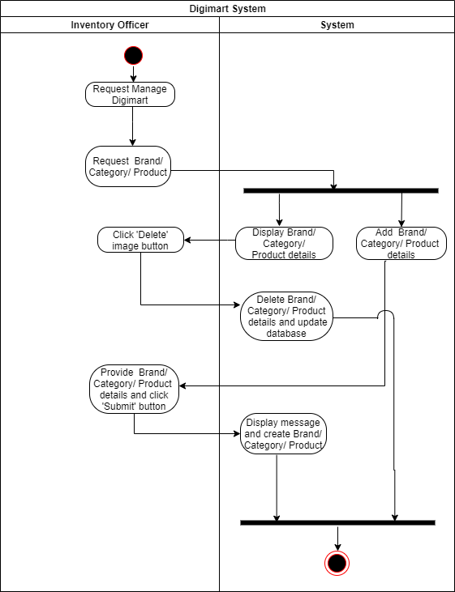

Figure : Activity Diagram - Add, Delete & View brand, product and category

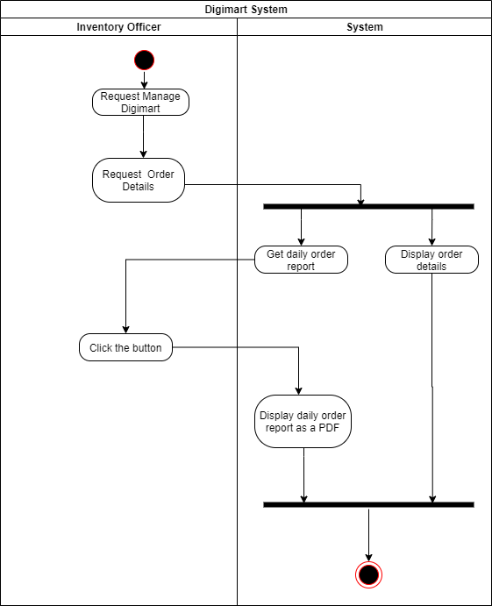

Figure : Activity Diagram - View order details & Get daily order report

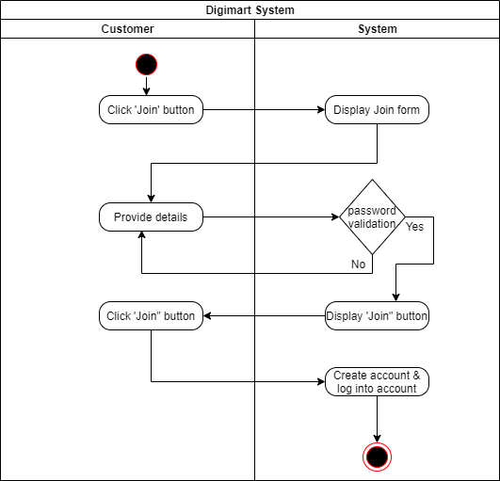

Figure : Activity Diagram - Create customer account

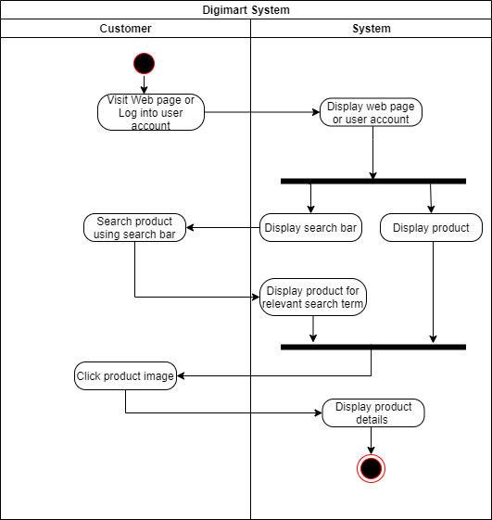

Figure : Activity Diagram - Search & View product

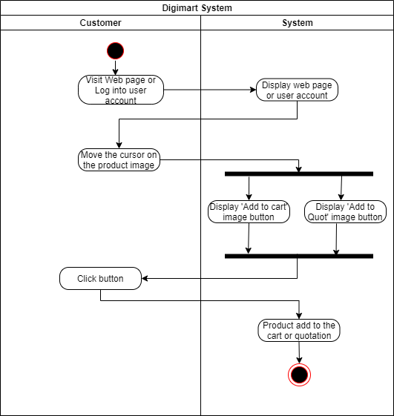

Figure : Activity Diagram - Add to cart or quotation

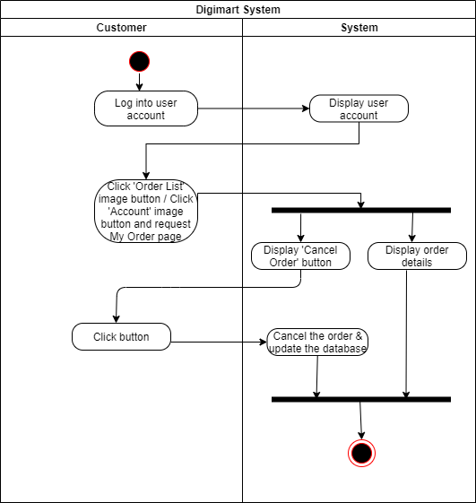

Figure : Activity Diagram - View & Cancel order details

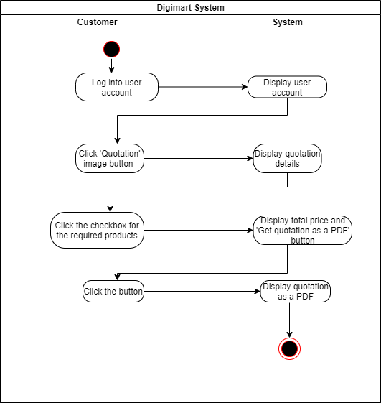

Figure : Activity Diagram - Get quotation

Figure : Activity Diagram - Place order for customized product

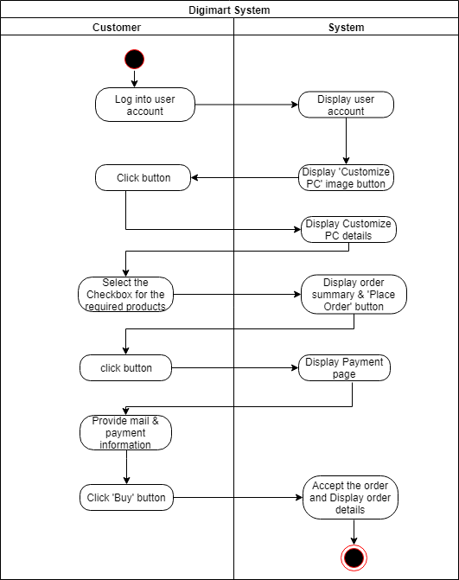

Figure : Activity Diagram - Buy product

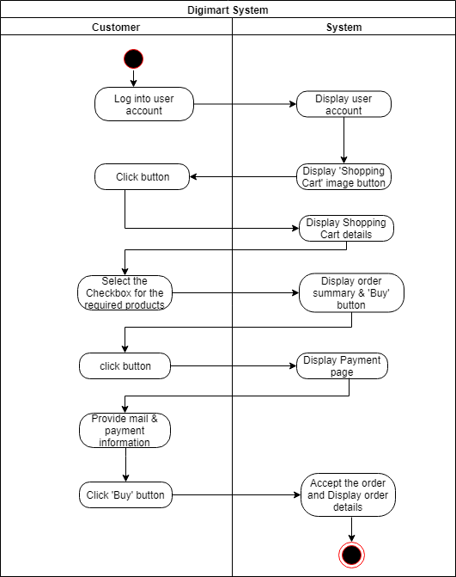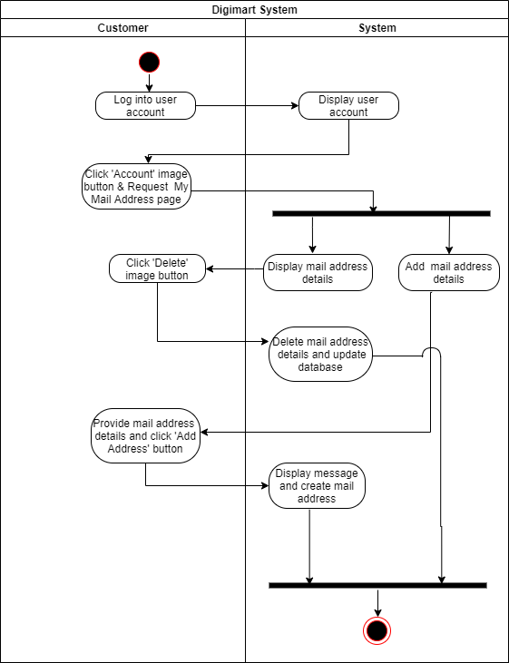

Figure : Activity Diagram - Add, Delete & View mail address

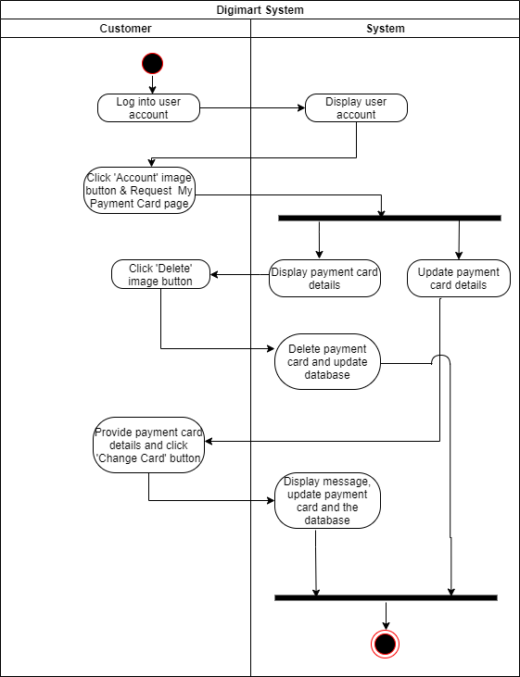

Figure : Activity Diagram - Update, Delete & View payment card

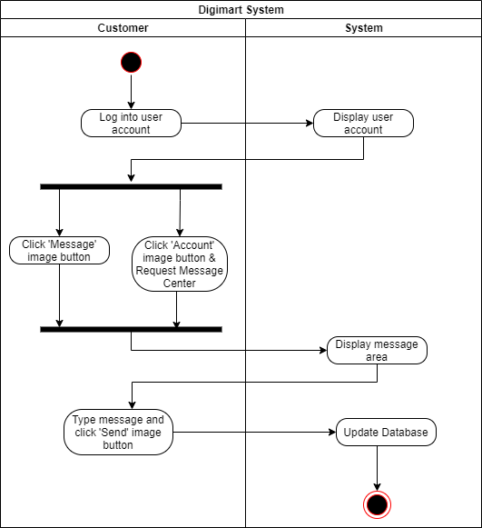

Figure : Activity Diagram - Send & View messages

## 2.6 Sequence Diagrams

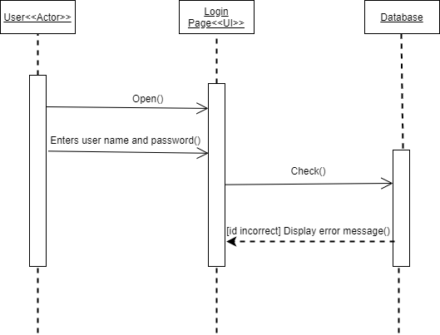

Figure : Sequence Diagram - Login

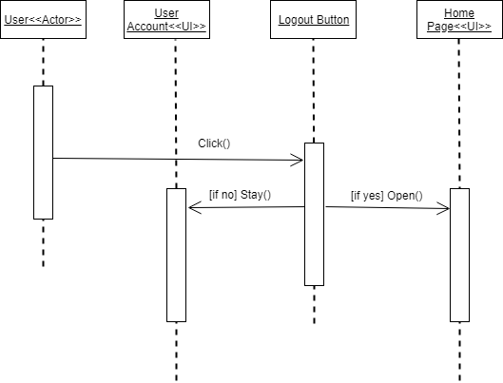

Figure : Sequence Diagram - Logout

Figure 25: Sequence Diagram – Update Profile

Figure : Sequence Diagram – View Dashboard

Figure : Sequence Diagram – Add, Delete & View user account

Figure : Sequence Diagram – View transaction details & Get monthly transaction report

Figure : Sequence Diagram – Add, Delete & View brand, product and category

Figure : Sequence Diagram – View order details & Get daily order report

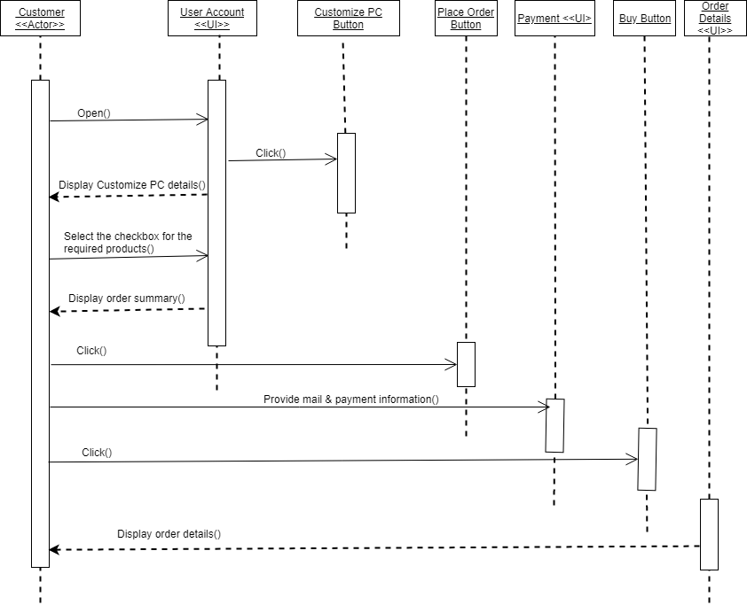

Figure : Sequence Diagram – Place order for customized product

Figure : Sequence Diagram - Buy product

## 2.7 Software Requirement Specification

### 2.7.1 Functional Requirement

A Functional Requirement is a document that describes the essential technical requirements of a system or feature, including the procedures by which it can be determined that requirements have been met. Following points describe the functional requirements of **Digimart**.

|  |  |
| --- | --- |
| **ID** | **Description** |
| **Admin** | |
| 1 | Shall be able to view dashboard. |
| 2 | Shall be able to create & delete Administrator, Inventory Officer & Customer. |
| 3 | Shall be able to view transactions details and get monthly transaction report. |
| 4 | Shall be able to view contact messages & reply. |
| 5 | Shall be able to maintain own profile. |
| **Inventory Officer** | |
| 1 | Shall be able to view dashboard. |
| 2 | Shall be able to maintain own profile. |
| 3 | Shall be able to add & delete Brand, Category & Brand |
| 4 | Shall be able to view order details and get daily order report |
| 5 | Shall be able to view contact messages & reply. |
| **Customer** | |
| 1 | Shall be able to create account & sign in. |
| 2 | Shall be able to view & search device details. |
| 3 | Shall be able to purchase devices. |
| 4 | Shall be able to view order details. |
| 5 | Shall be able to get quotation for customized product. |
| 6 | Shall be able to add & delete mail address. |
| 7 | Shall be able to update and delete payment card. |
| 8 | Shall be able to view reviews. |
| 9 | Shall be able to maintain own profile. |

Table - Functional Requirement

### 2.7.2 Non-Functional Requirement

Non-functional requirements are requirements that are not directly concerned with the specific functions delivered by the system. Following points describe the non-functional requirements of **Digimart**.

|  |  |
| --- | --- |
| **ID** | **Description** |
| **Soft Delete** | |
| 1 | A record has been deleted, instead of actually deleting the record. |
| **Cookies for login** | |
| 1 | When customer log in first time, if customer like to save username and password in cookies, customer can save. The next time the user logs in, the username and password will be filled in automatically. |
| **Password recovery by email** | |
| 1 | If the customer has forgotten the password, he or she can recovery the password. |
| **Responsive web design** | |
| 1 | Responsive layouts automatically adjust and adapt to any device screen size, whether it is a desktop, a laptop, a tablet, or a mobile phone |
| **Security** | |
| 1 | Only authorized users can access the system with username and password. |
| **Performance** | |
| 1 | Easy tracking of records and updating can be done. |
| **Modification** | |
| 1 | Any modification for the Database shall be synchronized and done only be the admin of the system. |

Table - Non-Functional Requirement

# Chapter 3: Implementation

## 3.1 Technologies

* **Digimart** is a web-based application.
* We used,
  + PHP
  + MYSQLI (It is the OOP version of **MySQL** extension)
  + HTML5 (It is the fifth and current major version of HTML)
  + CSS
  + JavaScript and jQuery v3.4.1
  + Bootstrap v4.3.1
  + tcpdf (for report generate)
  + Ajax

## 3.2 Program Techniques

* We use Sessions to store data for individual users against a unique session ID and persist state information between page requests.
* We use cookies to when customer log in first time, if customer like to save username and password in cookies, customer can save. The next time the user logs in, the username and password will be filled in automatically.
* Web pages linked to the database, using the get connection file and the connection is closed using a close connection file.

## 3.3 Coding

* Each process is coded in a separate file.
* Images, Web pages, JavaScript and CSS are stored in a separate folder.
* Use coding to prevent SQL injection.

# Chapter 4: Proposed System Interfaces

## 4.1 Proposed System Interfaces

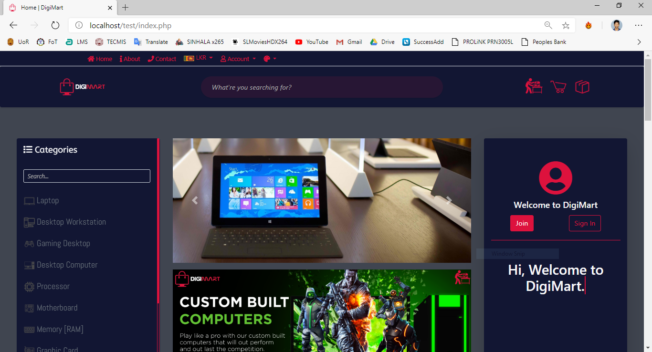

Figure : Home Page

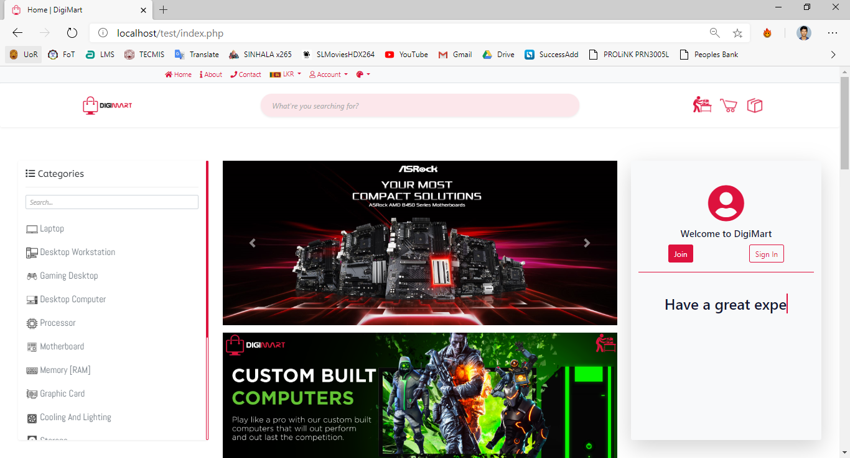

Figure : Light Theme

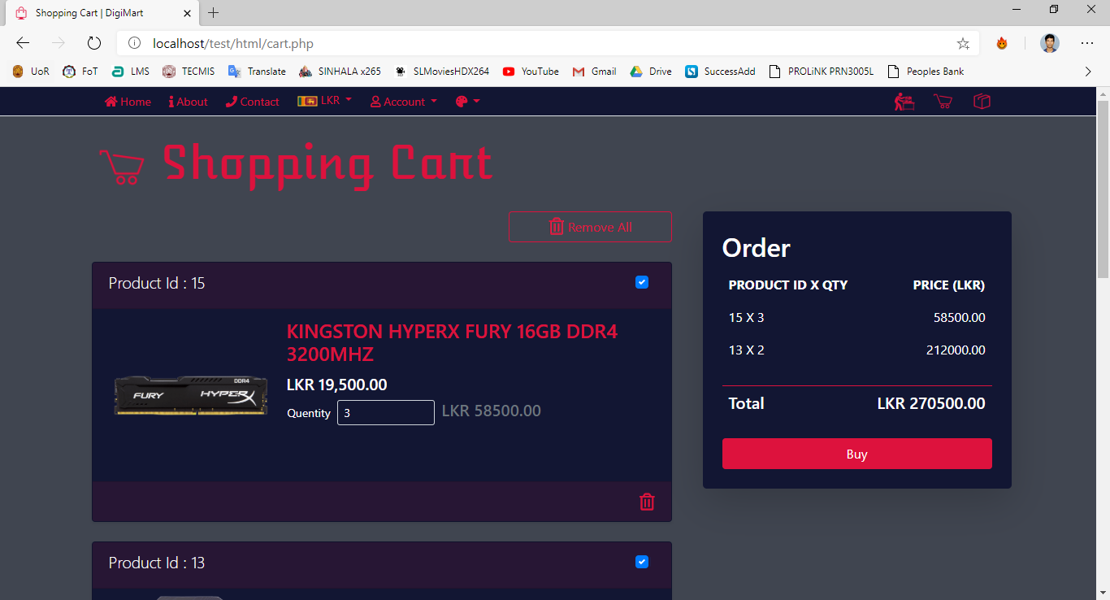

Figure : Shopping Cart

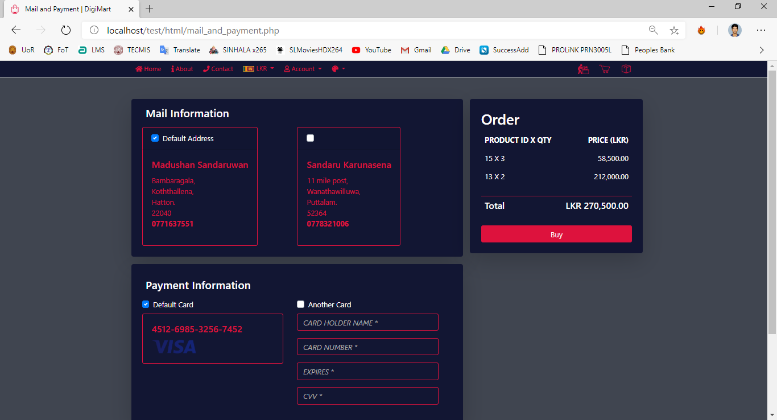

Figure : Mail and Payment Information

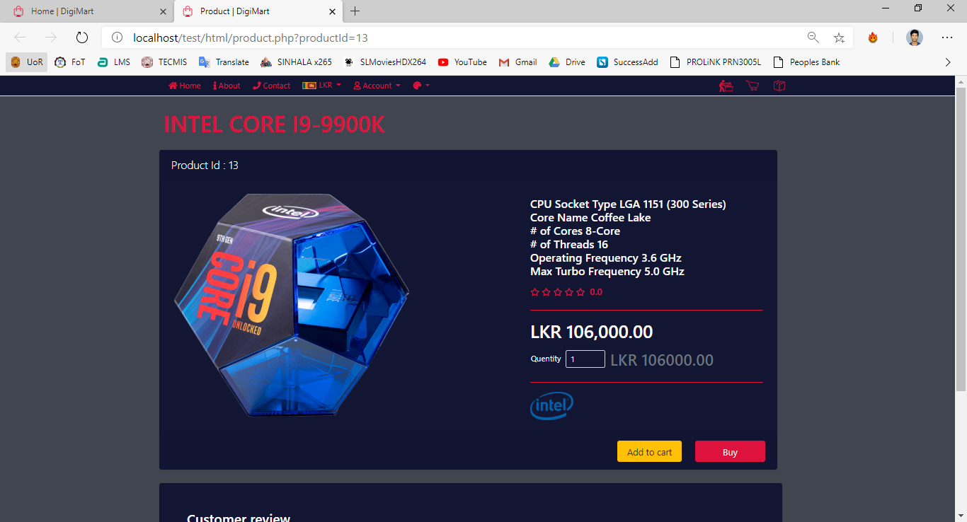

Figure : Product View

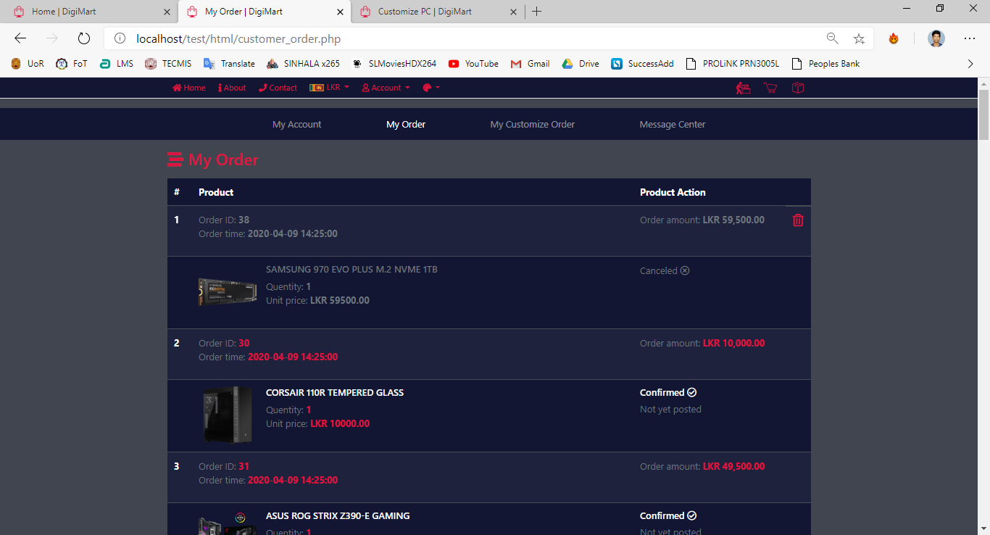

Figure : Customer Order Details

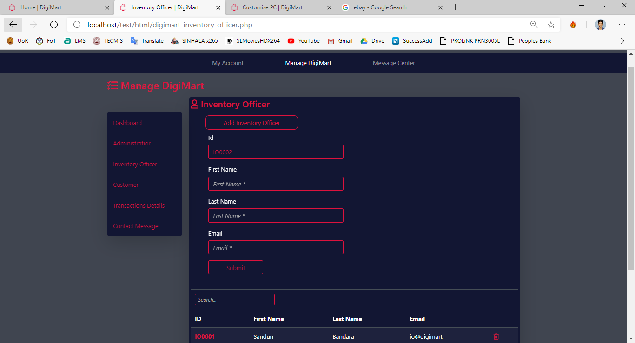

Figure : Add and View Inventory Officer

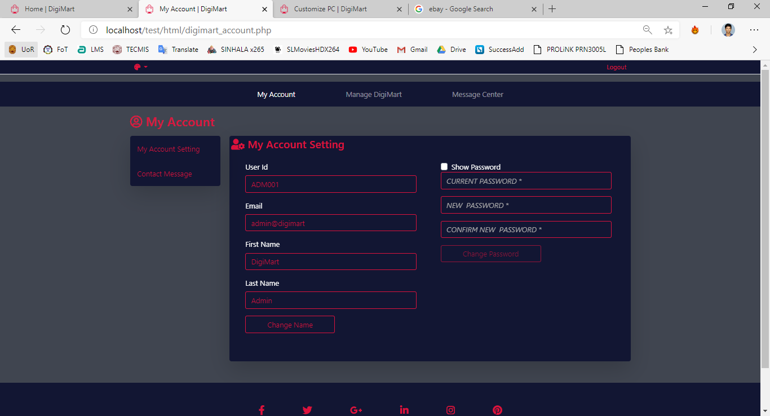

Figure : Account Setting

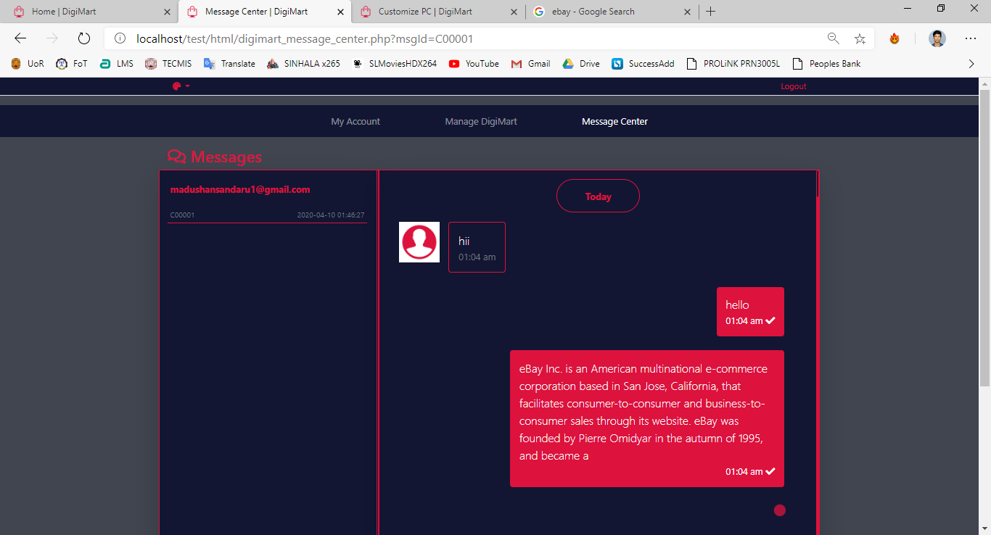

Figure : Message Center

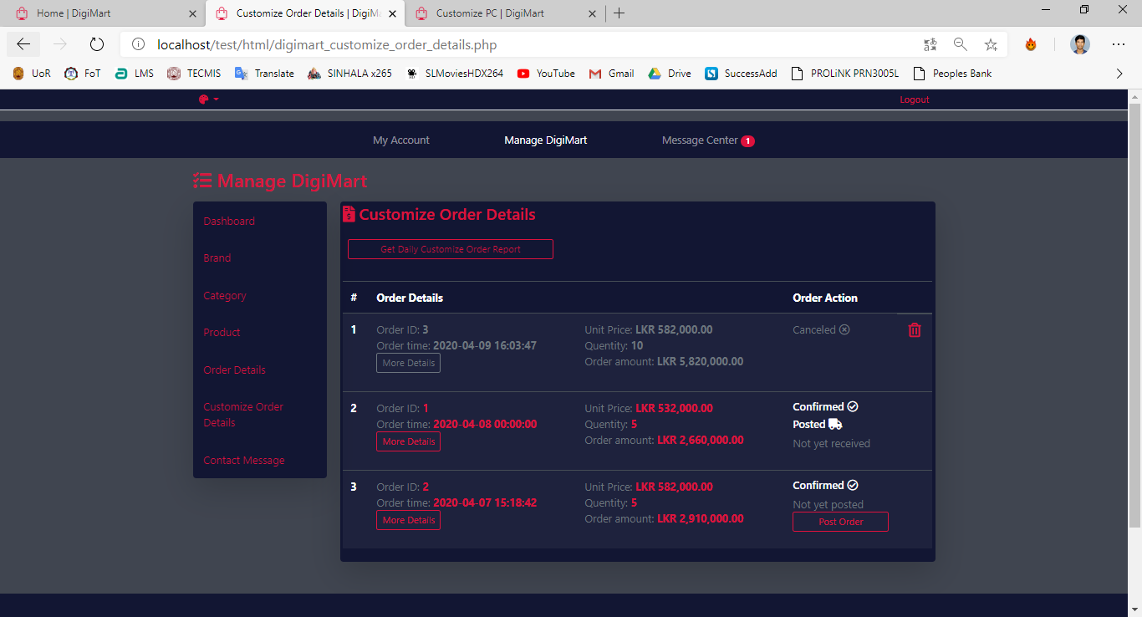

Figure : Customize Order Details

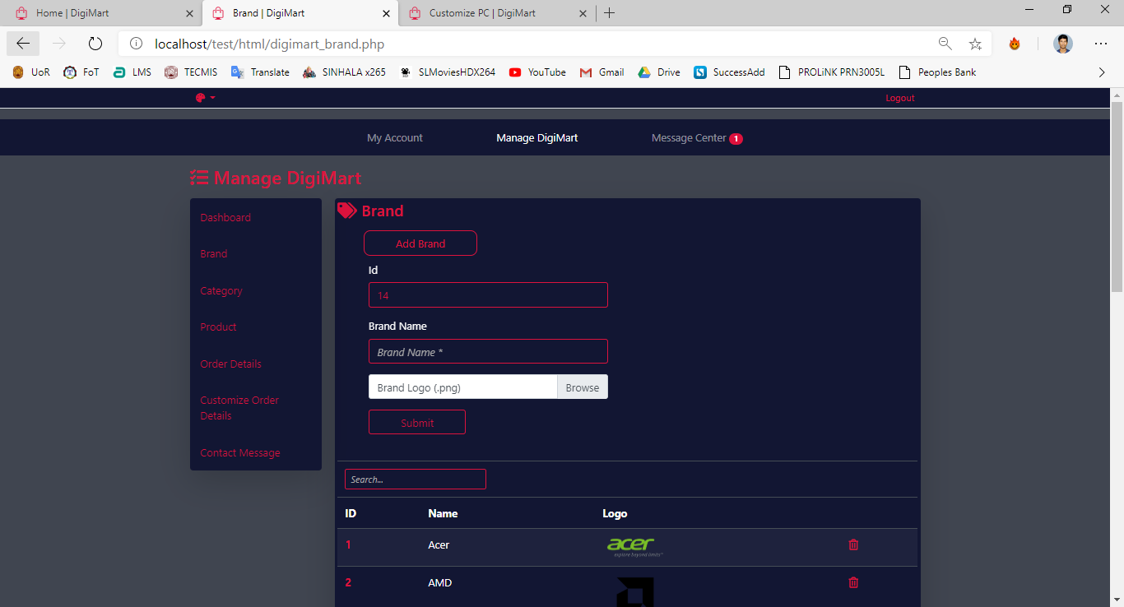

Figure : Add and View Product Brand

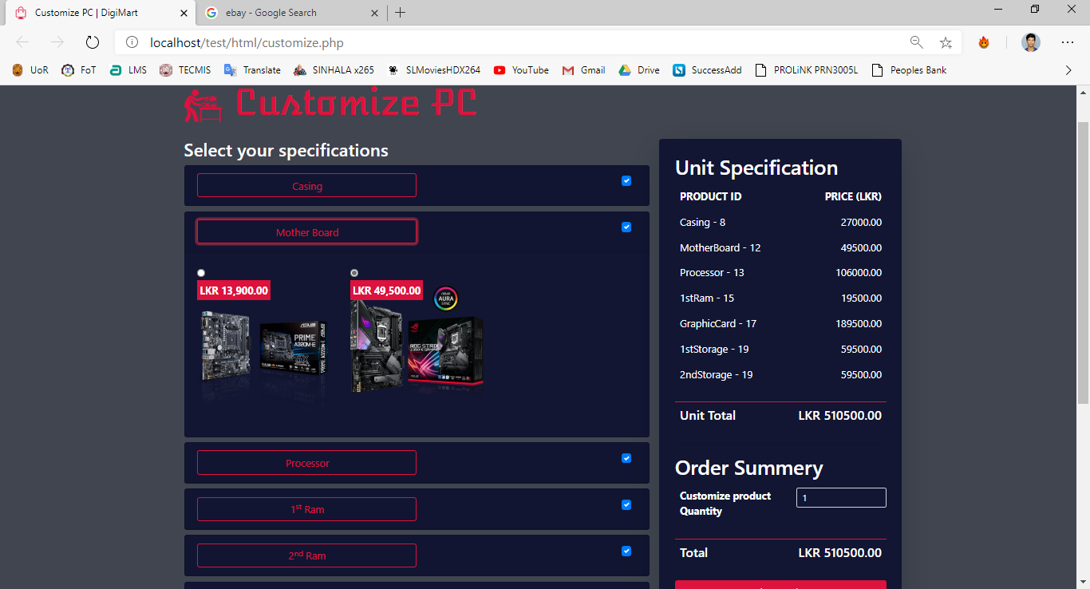

Figure : Customize Product Service

## 4.2 Report Design

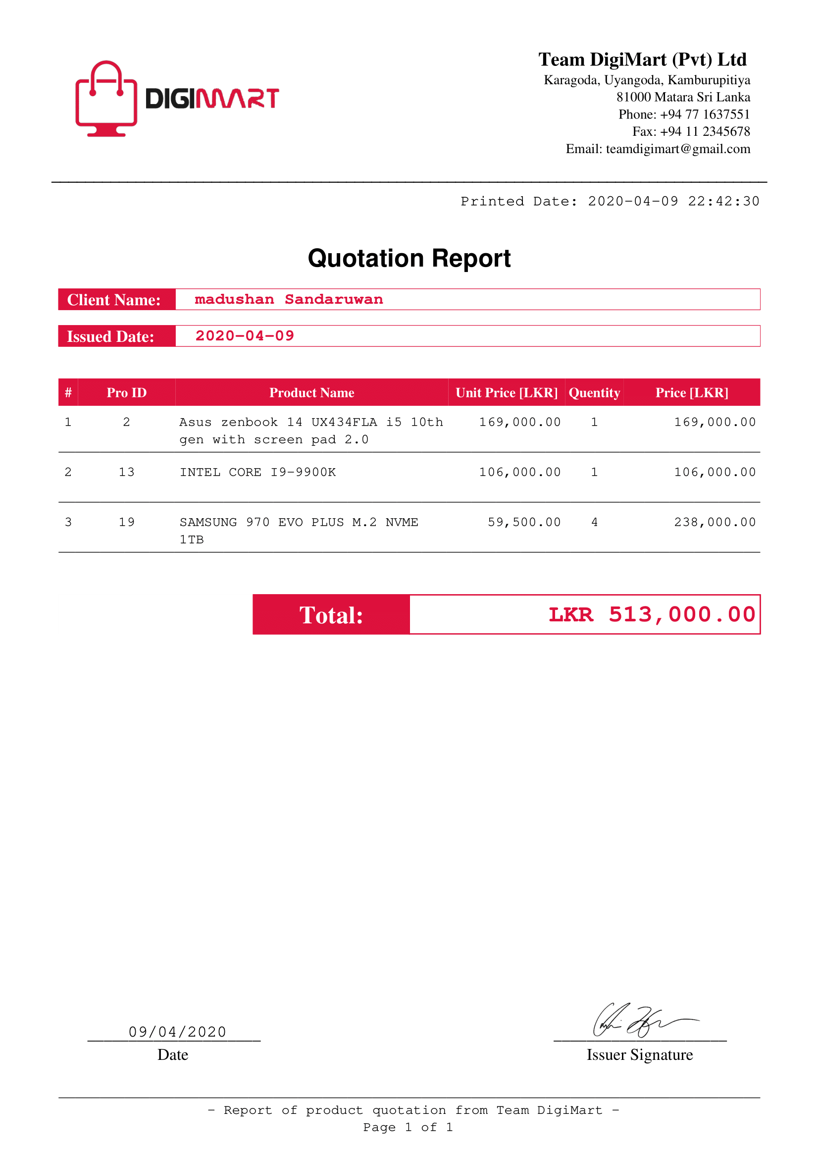

Figure : Quotation Report

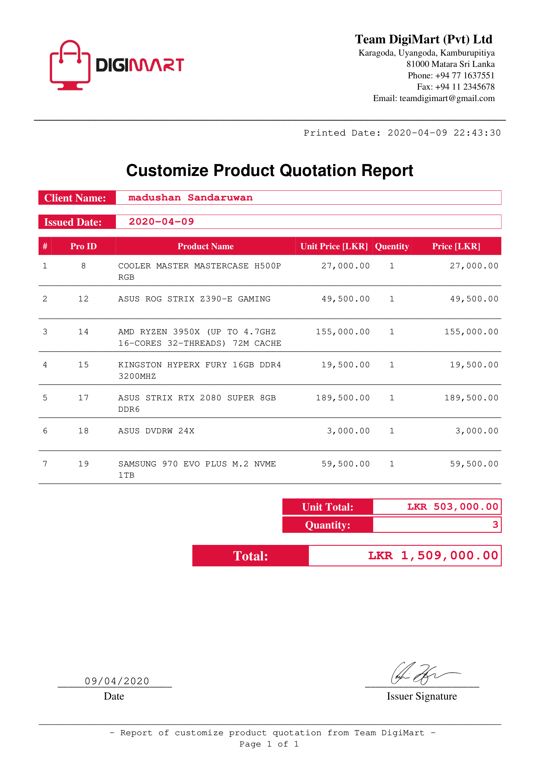

Figure : Customize Product Quotation Report

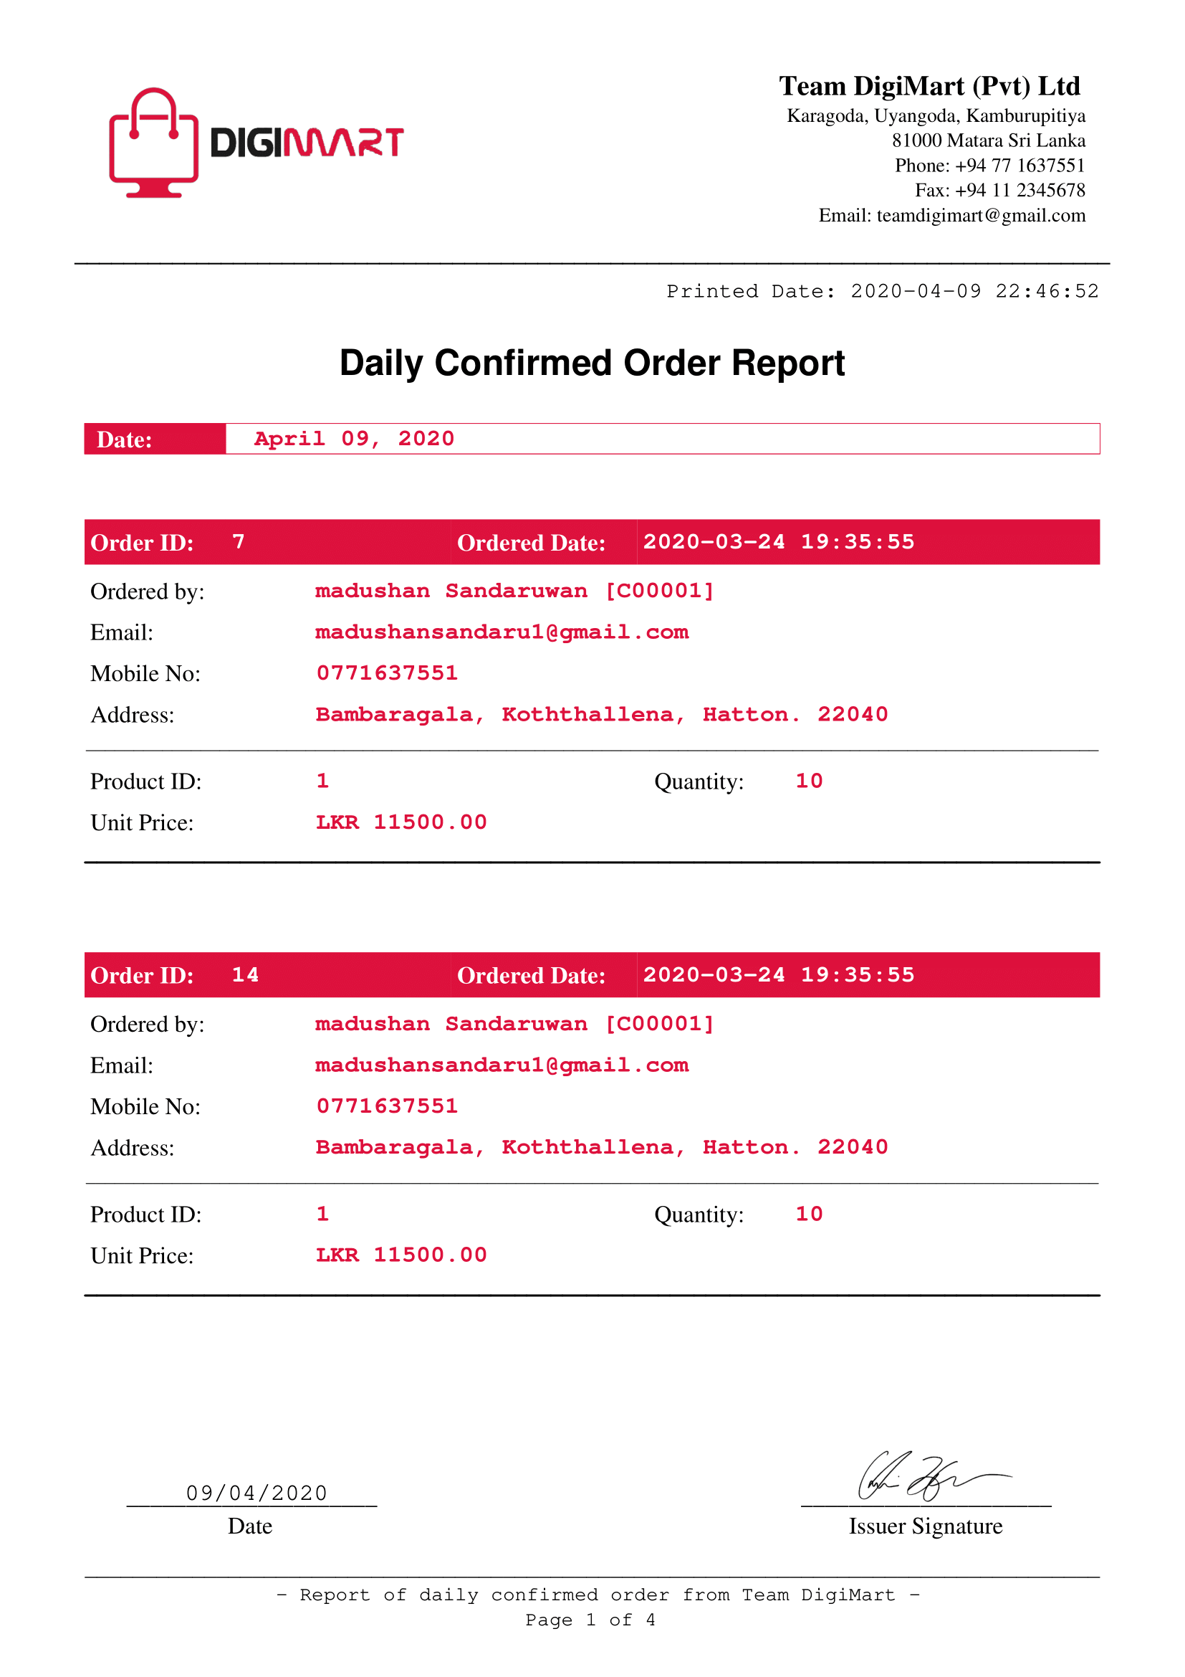

Figure : Daily Confirmed Order Report

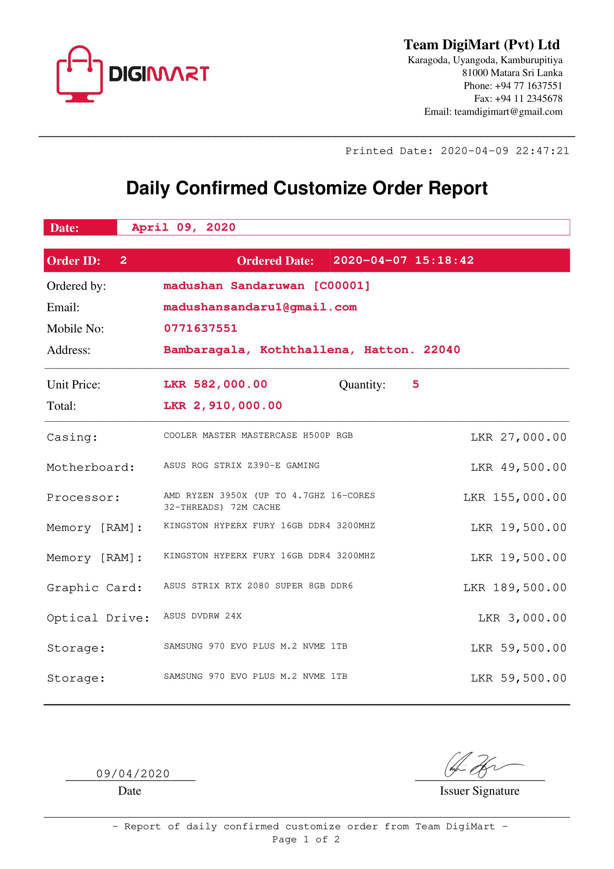

Figure : Daily Confirmed Customize Order Report

# Conclusion

We learned many new things as we did this project. we found out that there are many things that make each and every component computer different. Many companies now have a base model, but you cannot customize it however you want in this country through online. Now we are supposed to do which is not available in our country. You can choose your own components to put into the computer and they will build it specifically for you. From the outside many of these computers, laptops, PCs can look exactly alike but what's on the inside can be completely different.

While researching the topic we found a couple of references that had very good advice for people buying a laptop or computer or computer components. The first thing we would recommend is to be an educated shopper, research the products before going to the store so you know what is true and what's not so true when talking to a sales representative. The best advice we found was simply to know what you are looking for before you make a final decision. There are many different brands of each components, and each brand has many different models, and each model has many different ways it can be customized. You should find out what you will be using the component for so you know what you will need and what you won't use.

# References